**PRACTICAL –7**

**Q. Write a program to use IR ( Infrared ) Sensor to Respberry Pi .**

**IR sensors (Infrared sensor)** are modules which detect the presence of objects before them. If the object is present it give 3.3V as output and if it is not present it gives 0 volt. This is made possible by using a pair of **IR pair** (transmitter and receiver), the **transmitter (IR LED)** will emit an IR ray which will get reflected if there is a object present before it. This IR ray will be received back by the **receiver (Photodiode)** and the output will be made high after amplified using an op-amp link **LM358**. You can learn more about [IR Sensor Module Circuit](https://circuitdigest.com/electronic-circuits/ir-sensor-circuit-diagram) here.

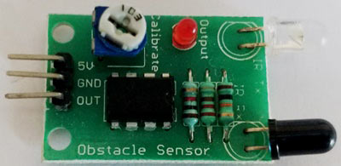

The IR Sensor used in this project is shown above. Like all IR sensor it has three pins which are 5V, Gnd and Out respectively. The module is powered by the 5V pin from Raspberry Pi and the out pin is connected to GPIO14 of Raspberry Pi. The potentiometer on top of the module can be used to adjust the range of the IR sensor.

**Hardware:-**

* Raspberry pi
* InfraredSensor (IR)
* LED
* 10k ohm potentiometer
* Breadboard and wires

**Code:-**

importRPi.GPIO as IO  
import time  
IO.setwarnings(False)  
IO.setmode(IO.BCM)

IO.setup(2,IO.OUT) #GPIO 2 -> Red LED as output  
IO.setup(3,IO.OUT) #GPIO 3 -> Green LED as output  
IO.setup(14,IO.IN) #GPIO 14 -> IR sensor as input

while 1:

    if(IO.input(14)==True): #object is far away  
        IO.output(2,True) #Red led ON  
        IO.output(3,False) # Green led OFF  
      
    if(IO.input(14)==False): #object is near  
        IO.output(3,True) #Green led ON  
        IO.output(2,False) # Red led OFF

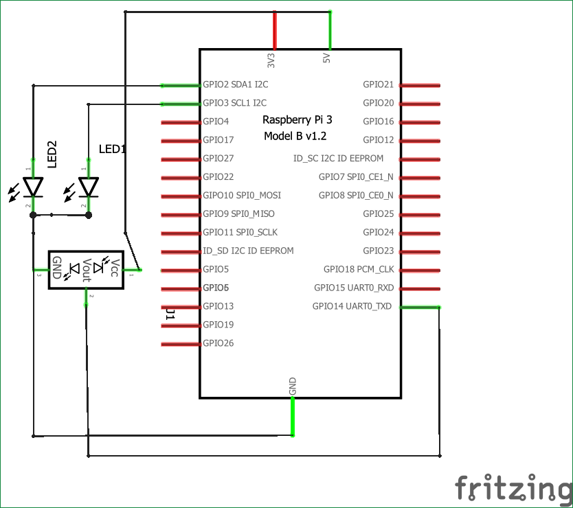

**OutPut:-**

